SOFTWARE REQUIREMENT SPECIFICATION (SRS)
Crop Disease Detection and Farm Advisory Platform
Scenario-Based Requirement Analysis
Course: Software Engineering
Course Code: CSA10 / CSA1063
CO Assessed: CO2
Student Name: HAASHINI P
Register Number: 192524047
Date: 25-10-2026
Purpose: This document defines requirements for a platform that helps farmers identify possible crop diseases from images and receive practical farm advisory information. The system supports decision-making and does not replace professional agricultural diagnosis.

1. Study and Analyze the Scenario
1.1 Business Domain
The proposed system belongs to the agriculture technology domain. It combines image-based crop disease screening with farm advisory services so farmers can access preliminary crop-health information, prevention practices, and recommended next steps.
1.2 Problem Description
Farmers may find it difficult to identify crop diseases early. Symptoms can be confusing, expert support may not be immediately available, and delayed action can contribute to crop loss. Disease prevention information may also be scattered across different sources. The proposed platform lets farmers submit crop images, receive possible disease results, and view relevant advisory information.
1.3 Stakeholders
- Farmers: submit crop images, review results, and use advisory recommendations.
- Agricultural experts: review uncertain or referred cases and provide guidance when expert review is available.
- System administrators: maintain user accounts, crop and disease information, and advisory content.
- Agricultural content specialists: provide validated information about symptoms, prevention, and farm practices.
- Platform owner or institution: oversees system quality, availability, and responsible use.
1.4 System Objectives
- Provide a simple way to submit crop images for disease screening.
- Display a possible disease classification with confidence or uncertainty information when available.
- Offer crop-specific prevention and farm advisory information.
- Maintain case history so farmers can review previous results.
- Allow authorized experts or administrators to improve advisory content.
- Protect user information and communicate the limitations of automated predictions.

2. Functional Requirements
FR-01 User registration and login: The system shall allow users to create an account and sign in securely.
FR-02 Farmer profile: The system shall allow farmers to maintain basic profile information and optional farm details such as location, crop type, and growing stage.
FR-03 Image upload: The system shall allow a farmer to upload or capture a crop image in a supported format and provide image-quality guidance.
FR-04 Image validation: The system shall validate file type, file size, and image availability before analysis.
FR-05 Disease screening: The system shall analyze a submitted image using the configured model and return a possible disease or healthy-crop result for supported classes.
FR-06 Result presentation: The system shall display the possible result, confidence or uncertainty information when available, common symptoms, and a notice that automated results may be incorrect.
FR-07 Farm advisory: The system shall provide relevant prevention practices, crop-care guidance, and recommended next steps associated with the crop or suspected disease.
FR-08 Case history: The system shall allow authenticated farmers to view previous submissions, dates, results, and associated advisory information.
FR-09 Expert review: Where enabled, the system shall allow an agricultural expert to review a referred or uncertain case and provide guidance.
FR-10 Feedback: The system shall allow farmers to report whether the result or advisory was useful and optionally provide comments.
FR-11 Content management: The administrator shall be able to add, edit, review, or deactivate crop, disease, symptom, and advisory records.
FR-12 Notifications: If enabled, the system may notify users when analysis is complete or an expert response is available.
FR-13 Search and filter: The system shall allow users to search or filter their own case history by crop, date, or result.
FR-14 Error handling: The system shall show understandable messages for unsupported images, failed analysis, network problems, or unavailable services.
3. Non-Functional Requirements
Performance: Under normal conditions, the system should return results within a reasonable response time; longer analysis should show a progress or status message.
Usability: The interface shall use clear labels, readable text, simple navigation, and understandable language for users with varied technical skills.
Security: The system shall authenticate users where required, apply role-based access, protect credentials, and prevent access to another farmer's private history.
Privacy: The system shall explain how images and farm data are used and retained, and collect personal or location data only when needed.
Reliability: The system shall handle invalid input and service failures gracefully without losing unrelated saved records.
Availability: The service should be available when needed, with planned maintenance communicated where possible.
Scalability: The architecture should support additional users, crops, disease classes, and advisory records without major redesign.
Maintainability: Models and advisory content should be updateable with documented changes and appropriate validation.
Compatibility: The interface should work on commonly used mobile and desktop browsers and supported devices.
Accuracy and transparency: The model should be evaluated on representative data and present predictions as possible results, not guaranteed diagnoses.

4. Actors and Use Cases
4.1 Actors
- Farmer (primary actor): registers or signs in, uploads crop images, views results and advisory information, and reviews case history.
- Agricultural Expert (secondary actor): reviews referred cases and provides additional guidance when enabled.
- Administrator (supporting actor): manages users, disease information, advisory content, and system settings.
4.2 Major Use Cases
- Register / Log in
- Maintain farmer profile
- Upload crop image
- Validate image
- View disease screening result
- View farm advisory
- View case history
- Submit feedback
- Review referred case
- Manage crop and disease data
- Manage advisory content and user accounts

4.3 Use Case Diagram
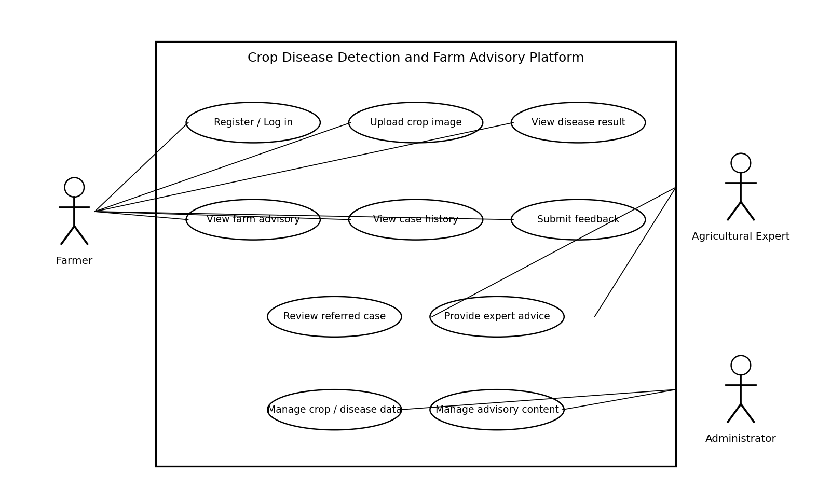
Figure 1: Use case diagram for the Crop Disease Detection and Farm Advisory Platform.
4.4 Use Case Descriptions
UC-01 Upload crop image and receive screening result: Primary actor: Farmer. Preconditions: The platform is available. Main flow: (1) The farmer selects a crop image. (2) The system validates its format and size. (3) The system starts analysis. (4) The system displays the possible result and confidence or uncertainty information when available. (5) Relevant advisory is displayed and the case is saved when history is enabled. Alternate flow: If the image is invalid or analysis fails, the system explains the problem and permits another attempt. Postcondition: A result or clear failure status is shown.
UC-02 View farm advisory: Primary actor: Farmer. Preconditions: Advisory content is available. Main flow: (1) The farmer opens the advisory section. (2) The system identifies relevant crop or suspected-disease information. (3) The system displays prevention steps and recommended actions. Alternate flow: If no matching advisory exists, the system states that information is unavailable and recommends contacting an agricultural expert. Postcondition: Applicable advisory information is displayed.
UC-03 Review a referred case: Primary actor: Agricultural Expert. Preconditions: The expert is authenticated and a case has been referred. Main flow: (1) The expert opens the assigned case. (2) The system displays the image and case details. (3) The expert records comments or advice. (4) The system stores the response for the farmer. Alternate flow: The expert requests a clearer image or more details. Postcondition: The case contains a response or request for more information.
UC-04 Manage disease and advisory content: Primary actor: Administrator. Preconditions: The administrator is authenticated with appropriate permission. Main flow: (1) The administrator opens content management. (2) Adds or updates crop, disease, symptom, or advisory information. (3) The system validates required fields. (4) The administrator saves the changes. Postcondition: Updated content is available to the platform.

5. Software Requirement Specification (SRS)
5.1 Scope of the System
The platform covers user access, crop-image submission, automated disease screening, result presentation, farm advisory display, case history, feedback, and administration of crop and disease information. Expert review and notifications are optional capabilities depending on implementation. The platform is a decision-support tool and does not guarantee a diagnosis or replace qualified agricultural advice.
5.2 Data Requirements
- User data: user identifier, authentication details, role, and optional contact or farm profile information.
- Crop image data: image file or reference, upload timestamp, selected crop information if provided, and processing status.
- Analysis data: predicted class, model version, confidence or uncertainty value if available, and timestamp.
- Advisory data: crop or disease association, recommendation text, source or reviewer, and last-updated date.
- Case history data: links between user, image, result, advisory, feedback, and expert response where applicable.
- Operational data: necessary records of administrative changes, failures, and security events subject to retention rules.
5.3 External Interface Requirements
- User interface: responsive screens for sign-in, image upload, results, advisory, history, and administration.
- Camera and file interface: device image capture or file selection where supported and permitted.
- Analysis interface: a service or model interface that accepts validated images and returns structured results.
- Notification interface: optional email, SMS, or in-app notification service if implemented.
- Network interface: secure communication between client, application server, database, and analysis service.
5.4 System Features
- Crop-image disease screening.
- Crop-specific farm advisory and prevention guidance.
- Case history and result review.
- Expert review workflow for uncertain or referred cases.
- Administration of crop, disease, and advisory information.
- Feedback collection for future quality improvement.

6. Assumptions and Constraints
6.1 Assumptions
- Farmers have access to a supported device and internet connection when using online features.
- Uploaded images are relevant to the crop and sufficiently clear for analysis.
- The disease-detection model and advisory dataset are supplied, configured, and maintained by the implementation team or authorized specialists.
- Advisory content is reviewed for relevance and safety before publication.
- Users understand that automated results may be uncertain and may require expert confirmation.
6.2 Constraints
- Technical: prediction quality depends on image quality, model coverage, training data, and supported crop or disease classes.
- Operational: expert review depends on expert availability and response time.
- Economic: hosting, storage, model inference, and notification services may be limited by budget.
- Legal and privacy: image and personal-data processing must follow applicable privacy and data-protection requirements.
- Time: development time may limit supported crops, languages, integrations, and analytics.
- Connectivity: weak internet access may delay uploads, analysis, or notifications.

7. Requirement Completeness and Consistency Validation
7.1 Completeness Checks
- All primary actors have been identified and mapped to relevant use cases.
- Functional requirements cover upload, validation, screening, results, advisory, history, feedback, and administration.
- Non-functional requirements cover performance, usability, security, privacy, reliability, availability, scalability, maintainability, compatibility, and transparency.
- Data requirements and external interfaces are described.
- Assumptions and constraints affecting delivery and reliability are documented.
7.2 Consistency and Ambiguity Checks
- The term 'possible disease result' avoids implying that automated predictions are always correct.
- Expert review and notifications are marked as optional where implementation-dependent.
- The system must not show a successful result when validation or analysis fails.
- Access controls must prevent farmers from viewing other users' private case histories.
- Supported file types, file-size limits, supported crops, measurable accuracy thresholds, and response-time targets must be finalized during detailed design and testing.
7.3 Suggested Improvements
- Evaluate the model on representative images under different lighting, growth stages, and field conditions.
- Provide a low-confidence pathway that requests a clearer image or recommends expert review.
- Support regional languages and low-bandwidth use where feasible.
- Maintain versioned disease and advisory content with expert review.
- Conduct usability tests with farmers and use feedback to improve navigation and wording.

8. Conclusion
The Crop Disease Detection and Farm Advisory Platform is intended to help farmers obtain preliminary crop-health information and relevant advisory guidance through one system. This SRS defines stakeholders, functional and non-functional requirements, actors, use cases, data and interface needs, assumptions, constraints, and validation checks. The platform should be evaluated transparently, with clear communication that automated results support but do not replace professional agricultural judgment.

